Vibe System Implementation

Preconditions (Inputs from Design Phase)
Implementation MUST NOT start unless the following artifacts exist and are approved:
- current_state.md (final, post-hardening design state)
- docs/adr/ (append-only, all major trade-offs recorded)
- docs/diagrams/ (C4: Context → Container → Component)
- docs/implementation-plan/ (high-level task mapping)
All implementation decisions must trace back to these inputs. Deviations require a new ADR.

Implementation Phases Overview
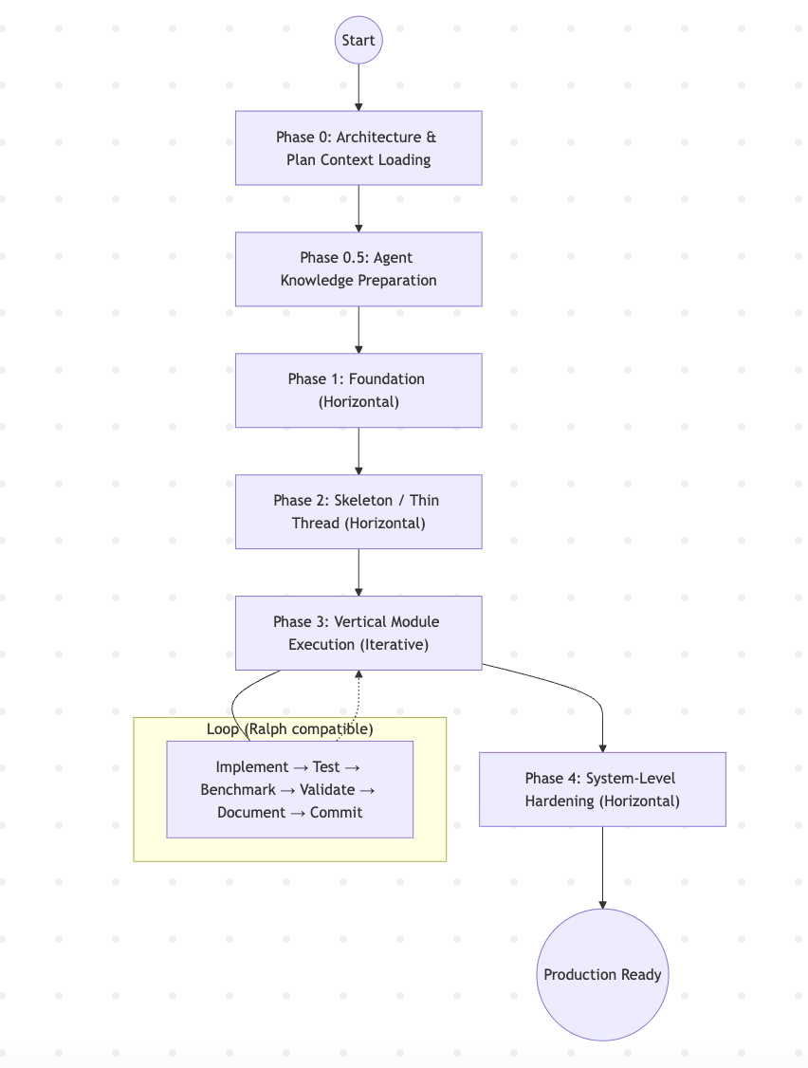
The phases are sequential at the system level, but Phase 3 is iterative per module.

Phase 0: Architecture & Plan Context Loading (Mandatory)
Implementation MUST NOT begin until the agent fully understands the approved architecture and execution plan.

Step 0.1 — Load Architecture Context
Goal: Internalize product intent, architectural decisions, and system boundaries.
Inputs (Authoritative):
- prd.md
- current_state.md
- docs/adr/
- docs/diagrams/
Agent Skill: .agent/skills/architecture-context-loader
Prompt Template:
@.agent/skills/architecture-context-loader
Load and internalize the approved architecture.
Inputs:
- @prd.md
- @current_state.md
- @docs/adr/
- @docs/diagrams/
Produce:
- Architecture summary
- ADR constraints list
- Container responsibility map
- Open questions (if any)
Do NOT propose changes.
Do NOT generate code.
Exit: Architecture is restored correctly with no hallucinated components.

Step 0.2 — Load Implementation Plan
Goal: Understand execution order, dependencies, and quality gates.
Inputs:
- docs/implementation-plan/README.md
- docs/implementation-plan/00-overview.md
Prompt Template:
Read and internalize the implementation plan.
Produce:
- Execution strategy summary
- Phase-by-phase outline
- Module dependency map
- Global quality gates
- System success criteria
Do NOT generate tasks.
Do NOT change scope or order.
Exit: Phases, dependencies, and ADR mappings are correctly understood.

Step 0.3 — Alignment Check
Goal: verify readiness before Phase 1.
Prompt Template:
Summarize:
- System goals
- Architectural constraints
- Implementation strategy
- Deliverables by phase
- Non-negotiable constraints
No new assumptions.
Exit: Summary matches current_state.md and implementation plan.

Phase 0.5: Agent Knowledge Preparation (Mandatory)
Before entering Phase 1: Foundation, the agent MUST prepare its execution environment, tools, and skills.
No infrastructure or feature work is allowed in this phase.

Tooling (MCPs)
The agent MUST load and be able to invoke the following MCPs when required:
- Third-party Integration MCP
For interacting with external services, APIs, and system tools.
- Context7 MCP
For tasks requiring web search, specification lookup, or verification.
- Dependency Knowledge MCPs
Language and ecosystem–specific sources used to select correct libraries and versions:
- docs.rs (Rust)
- pkg.go.dev (Go)
- npm, crates.io, or equivalents as required
Dependency selection MUST favor:
- stable releases
- active maintenance
- alignment with ADR constraints

Required Agent Skills
The following skills MUST be available and used explicitly during implementation:
- Test Writing Skill
Unit, integration, and end-to-end tests aligned with phase and module exit criteria.
- Benchmarking Skill
Micro and macro benchmarks on declared hot paths, with recorded results.
- Progress Logging Skill
Consistent updates to:
- implementation_state.md
- progress logs per phase or module
- Pull Request Writing Skill
Clear, reviewable PRs with:
- scope summary
- ADR references
- test and benchmark evidence

Exit Criteria
The agent may proceed to Phase 1: Foundation only when:
- All required MCPs are available
- All required skills are loaded
Skipping Phase 0.5 invalidates subsequent implementation work.

Phase 1: Foundation (Horizontal)

Goal
Establish all shared, system-wide prerequisites required for safe and repeatable development.
This phase is completed once and unblocks all downstream work.

Mandatory Deliverables
- Infrastructure provisioning (envs, networking, compute, storage)
- CI/CD pipelines with:
- build gates
- test execution
- artifact versioning
- Identity, secrets, and configuration management
- Observability baseline:
- structured logging
- metrics
- distributed tracing
- Shared libraries and platform services

Rules
- No feature code is allowed before this phase completes.
- CI must fail fast on:
- build errors
- test failures
- lint / formatting violations (if defined in ADRs)
- Observability must be wired before business logic.

Artifacts
- Infrastructure code
- CI/CD configuration
- Shared libraries
- implementation_state.md (Phase 1 marked complete)

Prompt template
@AGENTS.md @(relevant skills if needed) Execute Phase 1 following @docs/implementation-plan/01-phase-foundation.md.

Phase 2: Skeleton / Thin Thread (Horizontal)

Goal
Validate architectural connectivity end-to-end with minimal logic.
This phase answers: Does the system wire together as designed?

Scope
- Deploy minimal versions of all containers
- Establish authentication and authorization paths
- Implement contract stubs (schemas, APIs, message formats)
- Verify end-to-end request flow with placeholder logic

Non-Goals
- Business correctness
- Performance optimization
- Full error handling

Rules
- All containers must be deployable.
- All public contracts must compile and be callable.
- One or more end-to-end flows must succeed through the full system.

Exit Criteria
- System boots without manual intervention
- Requests traverse all intended boundaries
- Failures are observable via logs/metrics

Artifacts
- Minimal runnable system
- Contract definitions
- Smoke test results
- implementation_state.md updated

Prompt template
@AGENTS.md @(relevant skills if needed) Execute Phase 2 following @docs/implementation-plan/02-phase-skeleton.md.

Phase 3: Vertical Module Execution (Iterative)

Goal
Build the system module by module using vertical slices that reach production-grade quality independently.
Each module is treated as a mini-system.

Module Selection Order (already ordered in the implementation plan)
Modules MUST be prioritized by:
- Low dependency fan-in
- High architectural or technical risk
- High business value

Module Planning (Mandatory)
Before implementation, each module MUST have a detailed plan at:
docs/implementation-plan/<module_name>.md
The plan MUST specify:
- scope and responsibilities
- referenced ADRs
- contracts and schemas
- test strategy
- benchmark targets
- exit criteria
Implementation MUST NOT start without this plan.

Execution Model (Recommended)
Modules SHOULD be developed using the Ralph Wiggum Loop:
Implement → Test → Benchmark → Validate → Document
How to setup: https://github.com/AnyAxis-Labs/vibe-ralph-loop/blob/main/SETUP.md
The loop repeats until all module exit criteria are satisfied.
No step may be skipped.

Mandatory Work per Module
- Implement core business logic
- Fully implement public contracts
- Unit tests for domain logic
- Integration tests against real dependencies
- Module-scoped benchmarks on known hot paths
- Local enforcement of ADR-derived quality gates

Quality Gates (Non-Negotiable)
- Tests MUST pass in CI
- Benchmarks MUST be recorded
- Performance regressions MUST be explained or fixed
- Contract changes require ADR updates

Exit Criteria (Per Module)
- Independently verifiable correctness
- Observable behavior under load
- Production-grade readiness in isolation
Modules exit Phase 3 only when all criteria are met, regardless of overall system completeness.

Artifacts
- Production code
- Unit and integration tests
- Benchmark results
- Module implementation plan
- Progress logs
- implementation_state.md updated per module

Prompt template (without ralph loop)
@AGENTS.md @(relevant skills if needed) Implement the @docs/implementation-plan/0x-....md.

Phase 4: System-Level Hardening (Horizontal, Final)

Goal
Validate emergent system behavior that cannot be proven at module scope.
This phase assumes all modules are already hardened individually.

Mandatory Activities
- End-to-end workflow testing across modules
- Stress and load testing with realistic traffic
- Cross-module hot path benchmarking
- Failure mode validation:
- timeouts
- retries
- backpressure
- Operational readiness checks:
- alerts
- dashboards
- SLOs

Rules
- No new features are added in this phase.
- Only fixes, tuning, and operational improvements are allowed.
- Any architectural change requires returning to the design loop.

Exit Criteria
- The system meets defined performance and reliability targets
- Failure modes are observable and bounded
- On-call and operational artifacts exist

Artifacts
- System-level test reports
- Load and stress benchmark results
- Operational dashboards and alerts
- Final implementation_state.md

Governance and Change Control
- All implementation decisions trace back to ADRs.
- Any deviation requires:
- explicit documentation
- justification
- potential return to design phases
- Progress is tracked via:
- implementation_state.md
- structured progress logs
- CI/CD enforcement

Prompt template (without ralph loop)
@AGENTS.md (relevant skills if needed) Execute @docs/implementation-plan/08-phase-hardening.md

Summary
The Vibe System Implementation process is:
- Phase-based
- Prescriptive
- Evidence-driven
- Architecture-aligned
The system is considered production-ready only when all phases complete with their artifacts, benchmarks, and guarantees in place.

